How to Move a NetBeans Web Application from one Development PC to Another
when the Web App Does not have any Java Classes

Assume you are working on a NetBeans Web Application project and you want to move it to different computer (e.g., from CIS lab to home or vice versa) so that you can work on it some more – OR you want to install sample code that’s zipped in blackboard onto your home computer or a lab computer (so you can study and modify it).
- Send yourself a zip file of your project from the source computer.
  - Compose an email to yourself then click on “attach file”.
  - Browse to your project folder which would be stored under mydocs/NetBeansProjects. In the example below, the name of my project folder (to be zipped) was “Calc_Sample_Code”.
  - Right click your project folder and select “Send To – Compressed Zipped Folder”.
  - Select the newly created zip file (to attach) and send the email to yourself.
OR locate a zip file of sample code from the CIS 1056 website and download it.
- Unzip the project on the destination computer.
  - Find the zip file on the destination computer (icon is folder with zipper). Even though this zip file may look and act somewhat like a folder, it really is not a folder and cannot be used – until you extract the files.
  - Right click on the zip file and select “Extract All”. You can just accept the default location for the files to be extracted (which is just a folder next to the zip file, probably in your “downloads” folder ).
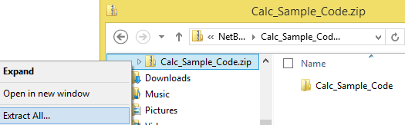
- From Windows Explorer, Copy Extracted Files from the “web” folder
  - Browse into the extracted files until you see the “web” folder.
  - Copy everything from the “web” folder EXCEPT the “WEB-INF” folder. This should include resources like style sheet files and image folders.
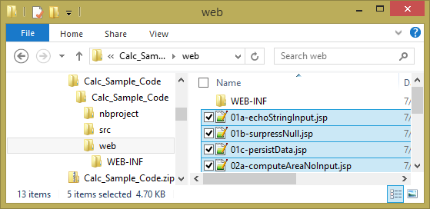

- In NetBeans, Create New Project and Paste in Files
  - Open up NetBeans and create a new Web Application Project on the destination computer. Then paste the files into the “Web Pages” folder (as shown in the NB Project Pane).
